**Promotional Task 2**

Here's the list of commands I used to create users for the Kodecamp Stores server, and assigned them to groups. I also created directories and assigned the right access to the right groups.

1. ~$ groupadd <group name>: this command creates a new group on the system.

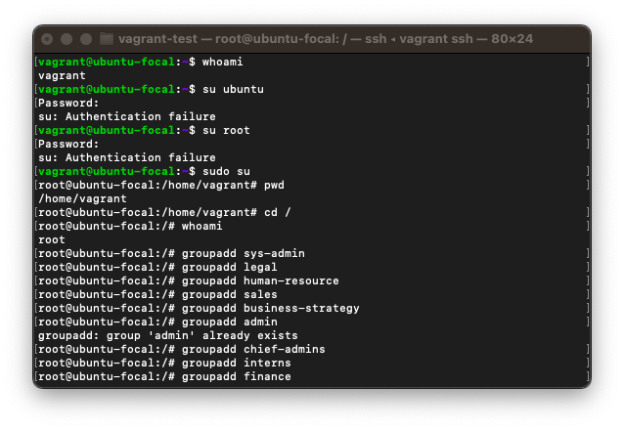

1. ~$ useradd -m -g <group name> <user name>: the useradd command is used to create a new user. I have used the -m flag to add a home directory for the user, and the -g flag to directly assign the new user to a group.

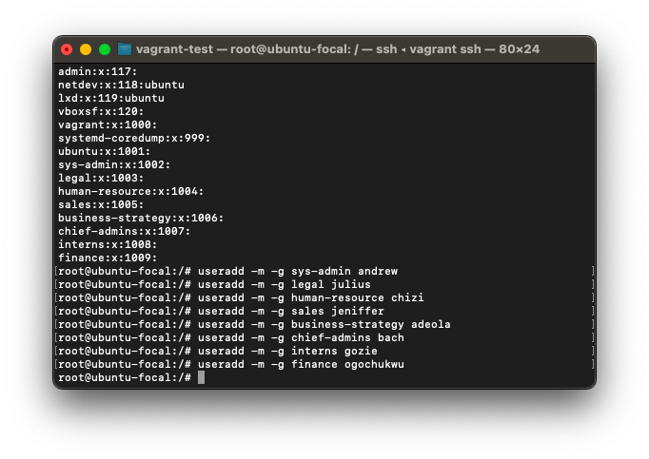

1. ~$ mkdir -p <path to dir>: the mkdir command is used to create a new directory. I’ve used the -p flag to ensure that any directory within the specified path that doesn't exist, gets created, to avoid errors being thrown.

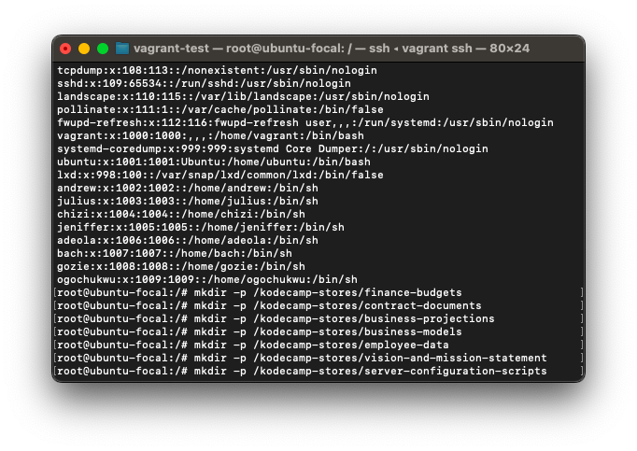

Here’s the current state of the directories created. One can notice they are owned by the root user, because that’s the account with which it was created.

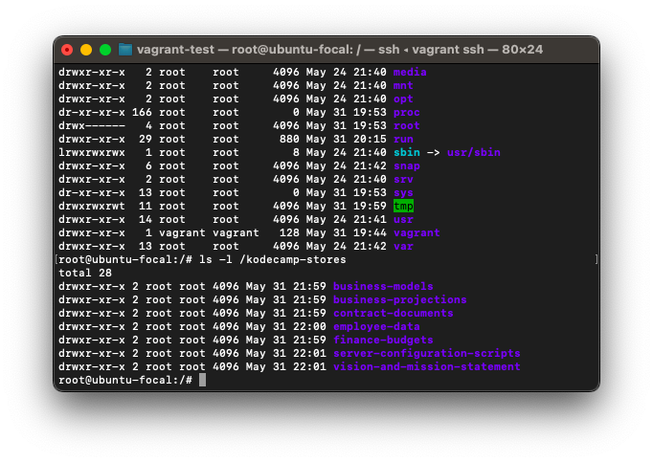

1. ~$ chown <user name>:<group name> <path to dir>: With this command I was able to change the owners of the directories to specific users and groups.

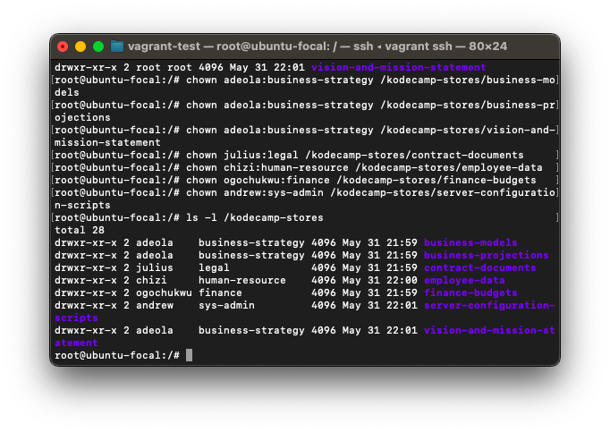

5. ~$ chmod <permissions> <path to dir>: Finally I used the chmod command to change/manage permissions on the file.

